Jodie Snodgrass
29 November 2025
CS 305
Module 5 certificate

Certificate authority or known as CA is used to verify the authenticity and trustworthiness of websites, domains, and organizations. With a CA users know who they're communicating with online and whether they could or could not be trusted. The certificate validates authenticity by using keys to prove authentic and trustworthy sources. Using encryption after being verified authentic with correct keys shows that CAs can be used to provide solid security to a company’s customers. With this solid security on a regular basis customers could feel more secure with a company’s website, domain, or organization making them a return customer and boosting company business (Awati R. & Loshin P., 2025).
I used the command line after created the keystore and put in all information but it did not ask for a password. 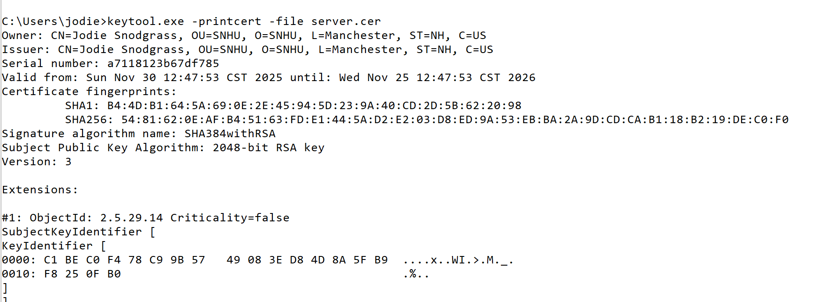Once the cer file was created I exported into desktop placed it under trusted root certification authorities folder. For some reason view certificate is grayed out and wont let me click it. 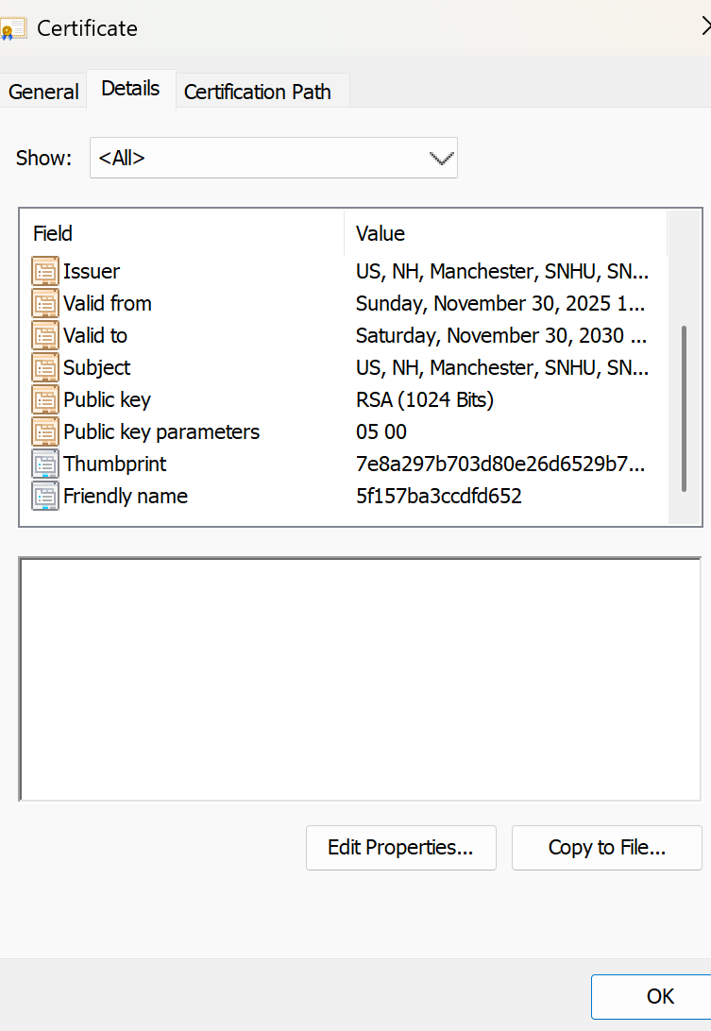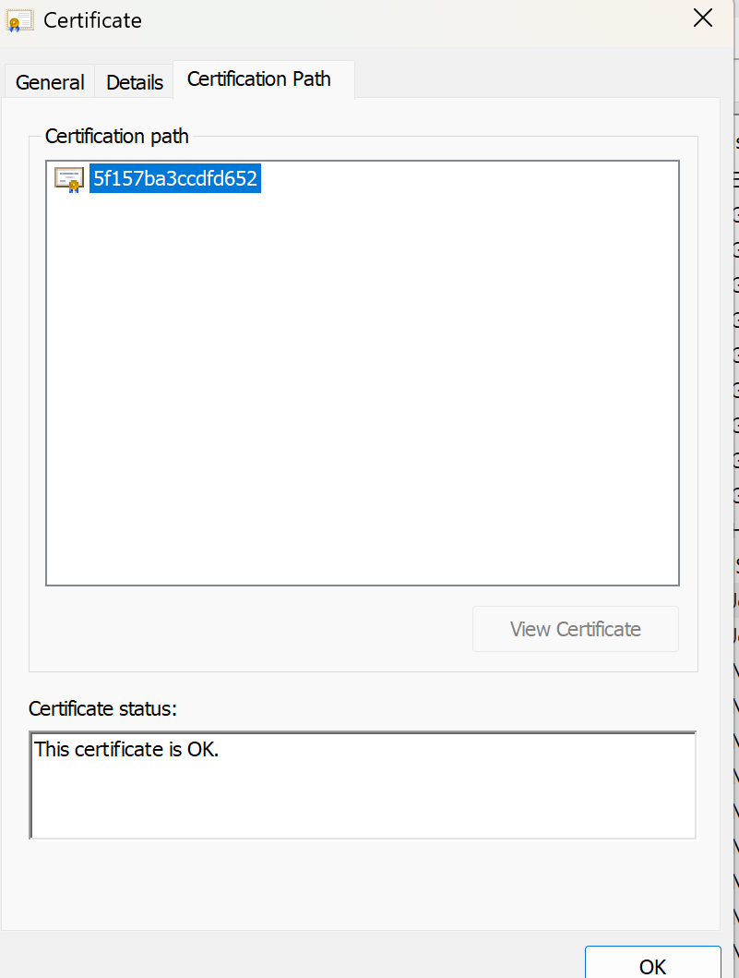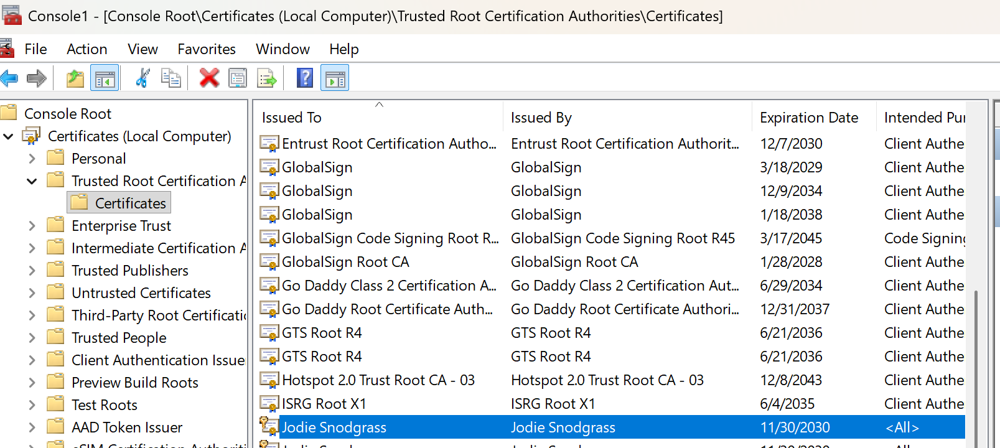

References
Awati, Rahul & Loshin, Peter. (Mar 07, 2025). TechTarget. What is certificate authority (CA)?.
https://www.techtarget.com/searchsecurity/definition/certificate-authority.

